

***J-Component Report ECE2010***

# CONTROL SYSTEMS

***Winter semester 2018-2019***

# Bidirectional visitor counter

***Submitted by:***

## Name: J.Bhanoday , Reg. no: 17BEC0209

## Name: NITHISH.M, Reg. no: 17BEC0413

## Name: B K HEM CHARAN , Reg. no: 17BEC0189

***Submitted to:***

***Dr.Malaya kumar hota sir***

**Abstract:-**

The project of “**Digital visitor counter**” is based on the interfacing of some components such as sensors, motors etc. with arduino microcontroller. This counter can count people in both directions. This circuit can be used to count the number of persons entering a hall/mall/home/office in the entrance gate and it can count the number of persons leaving the hall by decrementing the count at same gate or exit gate and it depends upon sensor placement in mall/hall. It can also be used at gates of parking areas and other public places. This project is divided in four parts: sensors, controller, counter display and gate. The sensor would observe an interruption and provide an input to the controller which would run the counter increment or decrement depending on entering or exiting of the person. And counting is displayed on a 16x2 LCD through the controller.

When any one enters in the room, IR sensor will get interrupted by the object then other sensor will not work because we have added a delay for a while.

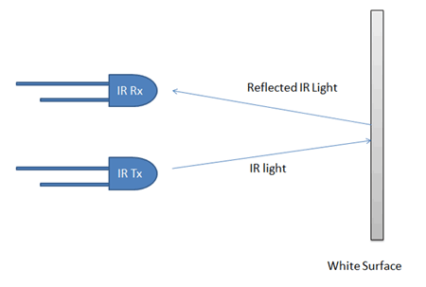

***INTRODUCTION:-***

There are some sections of whole visitor counter circuit that are sensor section, control section, display section and driver section.

## IR Sensor Circuit

## 

**Sensor section:** In this section we have used two IR sensor modules which contain IR diodes, potentiometer, Comparator (Op-Amp) and LED’s. Potentiometer is used for setting reference voltage at comparator’s one terminal and IR sensors sense the object or person and provide a change in voltage at comparator’s second terminal. Then comparator compares both voltages and generates a digital signal at output. Here in this circuit we have used two comparators for two sensors. LM358 is used as comparator. LM358 has inbuilt two low noise Op-amp.

**Control Section:** Arduino UNO is used for controlling whole the process of this visitor counter project. The outputs of comparators are connected to digital pin number 14 and 19 of arduino. Arduino read these signals and send commands to relay driver circuit to drive the relay for light bulb controlling. If you find any difficulty in working with relay, check out this tutorial on [arduino relay control](https://circuitdigest.com/microcontroller-projects/arduino-relay-control) to learn more about operating relay with Arduino.

**Display section:**  Display section contains a 16x2 LCD. This section will display the counted number of people and light status when no one will in the room.

**Relay Driver section:** Relay driver section consist a BC547 transistor and a 5 volt relay for controlling the light bulb. Transistor is used to drive the relay because arduino does not supply enough voltage and current to drive relay. So we added a relay driver circuit to get enough voltage and current for relay. Arduino sends commands to this relay driver transistor and then light bulb will turn on/off accordingly.

### **Visitor Counter Circuit Diagram:**

The outputs of IR Sensor Modules are directly connected to arduino digital pin number 14(A0) and 19(A5). And Relay driver transistor at digital pin 2. LCD is connected in 4 bit mode. RS and EN pin of LCD is directly connected at 13 and 12. Data pin of LCD D4-D7 is also directly connected to arduino at D11-D8 respectively. Rest of connections are shown in the below circuit diagram.

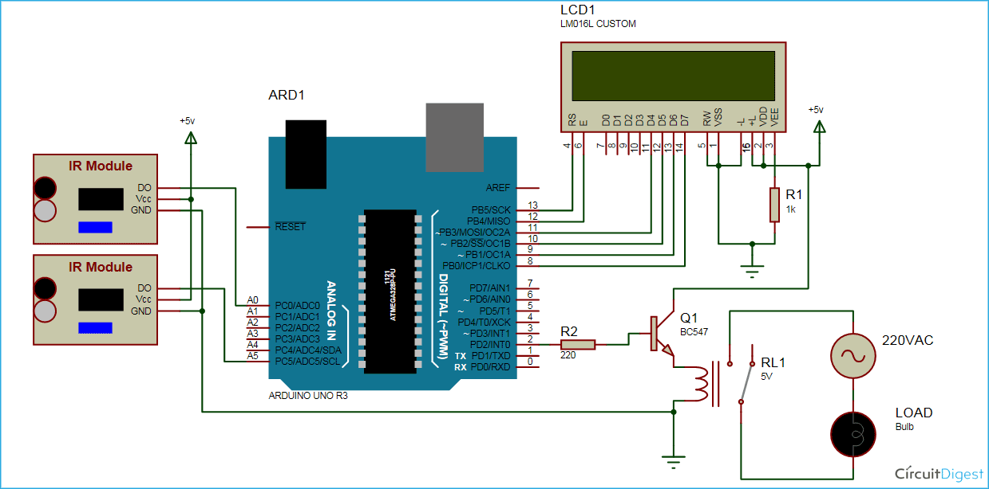

**Working of bi-directional visitor counter:**

When the system is powered ON, the microcontroller initially initializes the stack pointer and all other variables. It then scans the input pins (P2.0 and P2.1).

In the meantime, when there is no object in front of the IR Sensors, the light from the IR LED would not fall on the Photo Diode of the first sensor pair and hence, the Photo Diode doesn’t conduct.

As a result, the output of the IR sensors is LOW. In other words, ports P2.0 and P2.1 are at logic LOW level. If there is a person in front of the IR Sensors, IR light from the IR LED reflects from the person and falls on the Photo Diode.

As a result, the Photo Diode starts conducting and the output of the sensor becomes HIGH. In other words, the ports P2.0 and P2.1 are at logic HIGH level.

Now when a transition takes place, i.e. a logic HIGH level is received, first at port P2.0 and then at P2.1, the microcontroller sees this as an interruption to sense the passage or entry of a person or an object in front of the IR LED and the Photo Diode.

As per the program, the count value is increased and this value is displayed on the 16 x 2 LCD Display.

If the microcontroller senses logic HIGH, first on the P2.1 and then on P2.0, it assumes that the person is leaving the room and as per the program, the microcontroller decreases the count as displays the same on the LCD.

The program ensures that the count is increased or decreased only when both the sensors detect the person.

### **Applications of Bidirectional Visitor Counter Circuit:**

1. The Bidirectional Visitor Counter using 8051 Microcontroller circuit can be used domestically to get an indication of number of persons entering a party
2. It can be used at official meetings.
3. It can be used at homes and other places to keep a check on the number of persons entering a secured place.
4. It can also be used as home automation system to ensure energy saving by switching on the loads and fans only when needed.

#### **Limitations of this Circuit**

1. It is a low range circuit and cannot be implemented at large areas.
2. With frequent change in the count value, after a certain time the output may look confusing.

***MATERIELS AND METHOLOGY:-***

* Arduino UNO
* Relay (5v)
* Resisters
* IR Sensor module
* 16x2 LCD display
* Bread Board
* Connecting Wires
* Led
* BC547 Transistor

**Code explanation:**

First we have included library for LCD and defined pin for the same. And also defined input output pin for sensors and ralay.

**#include<reg51.h>**

**#define lcd P1**

**sbit rs=P3^6;**

**sbit e=P3^7;**

**sbit relay=P0^0;**

**sbit s1=P2^0;**

**sbit s2=P2^1;**

**void delay (int);**

**void cmd (char);**

**void display (char);**

**void init (void);**

**void string (char *);**

**void view (int);**

**int count=0;**

**int no[10]={48,49,50,51,52,53,54,55,56,57};**

**void delay (int d)**

**{**

**unsigned char i=0;**

**for(;d>0;d--)**

**{**

**for(i=250;i>0;i--);**

**for(i=248;i>0;i--);**

**}**

**}**

**void cmd (char c)**

**{**

**lcd=c;**

**rs=0;**

**e=1;**

**delay(5);**

**e=0;**

**}**

**void display (char c)**

**{**

**lcd=c;**

**rs=1;**

**e=1;**

**delay(5);**

**e=0;**

**}**

**void string (char *p)**

**{**

**while(*p)**

**{**

**display(*p++);**

**}**

**}**

**void view (int n)**

**{**

**cmd(0xc0);**

**display(no[(n/10)%10]);**

**display(no[n%10]);**

**}**

**void init (void)**

**{**

**cmd(0x38);**

**cmd(0x0c);**

**cmd(0x01);**

**cmd(0x80);**

**}**

**void main()**

**{**

**init();**

**string("counter........");**

**cmd(0xc0);**

**view(count);**

**while(1)**

**{**

**if(s1==1)**

**{**

**while(s2==0);**

**if(count!=99)**

**count=count+1;**

**while(s2==1);**

**view(count);**

**}**

**else if(s2==1)**

**{**

**while(s1==0);**

**if(count!=0)**

**count=count-1;**

**while(s1==1);**

**view(count);**

**}**

**else if(count==1)**

**relay=0;**

**else if(count==0)**

**relay=1;**

**}**

**}**

**Relay:**

[***Relay***](https://circuitdigest.com/article/relay-working-types-operation-applications) ***is an electromagnetic switch, which is controlled by small current, and used to switch ON and OFF relatively much larger current. Means by applying small current we can switch ON the relay which allow much larger current to flow. Relay is the good example of controlling the AC (alternate current) devices, using a much smaller DC current. Commonly used Relay is Single Pole Double Throw (SPDT) Relay, it has five terminals as below:***

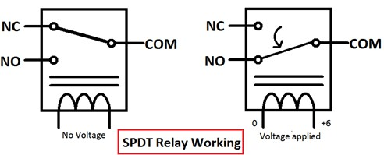

***When there is no voltage applied to the coil, COM (common) is connected to NC (normally closed contact). When there is some voltage applied to the coil, the electromagnetic field produced. Which attract the Armature (lever connected to spring), and COM and NO (normally open contact) gets connected, which allow larger current to flow. Relays are available in many ratings, here we used 6V operating voltage relay, which allow 7A-250VAC current to flow.***

***Relay is configured by using a small Driver circuit which consist a Transistor, Diode and a resistor. Transistor is used to amplify the current so that full current (from the DC source – 9v battery) can flow through coil to fully energies it. Resistor is used to provide biasing to transistor. And Diode is used to prevent reverse current flow, when the transistor is switched OFF. Every Inductor coil produces equal and opposite EMF when switched OFF suddenly, this may cause permanent damage to components, so Diode must be used to prevent reverse current. A Relay module is easily available in the market with all its Driver circuit on the board or you can create it by using above components. Here we have used 6V Relay module.***

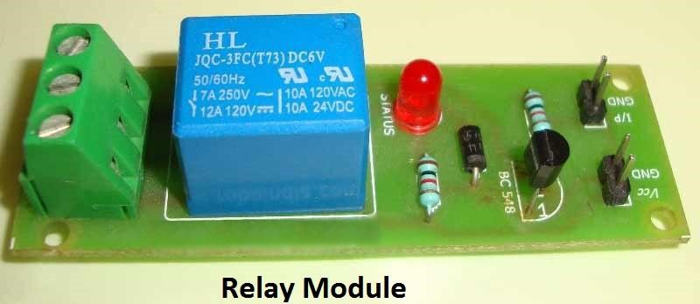

***RESULT AND DISCUSSION:-***

***The prototype has been tested in variable real life conditions to verify the overall functionality and seek better performance. The measurements collected during the test phase allow calculating energy savings so that it is possible to estimate cost savings and the number of persons count for larger systems using approximations. It can be used in malls to know the count of number of people entering and leaving the mall. It reduces the labor charge switching is done manually there is no need of human resource for both the counting and switching purpose.***

***CONCLUSION:-***

***A new model is presented in this paper which will reduce the power consumption of the street lighting system about 20-35 % compared to conventional design. Here we are saving lot of power without any Wastage, by these advanced technologies we can design many more systems which can be done by solar lights and through these solar lights we have a vast usage at the same time we can do automatic systems instead of doing it manually. Secondly, the bidirectional visitor counter quite easily tells you the no of people with lower expensive items like IR sensors and the aurdino.***

***REFERENCE:-***

1. <https://www.youtube.com/watch?v=1daQqfDJC-U>
2. <https://www.youtube.com/watch?v=0KipFKBNvz4>
3. https://www.electronicshub.org/bidirectional-visitor-counter-using-8051-microcontroller/